Kforce Login Process Guide
This document provides step-by-step instructions for completing the Kforce login, MFA setup, and Outlook & Microsoft Teams web access process.

Step 1: Open Microsoft 365 Login Page
Open Microsoft Edge / Google Chrome or any web browser and search for 'Office 365 Sign In' or directly open the Microsoft Outlook login page. “ https://www.microsoft.com/en-us/microsoft-365/outlook/log-in ”
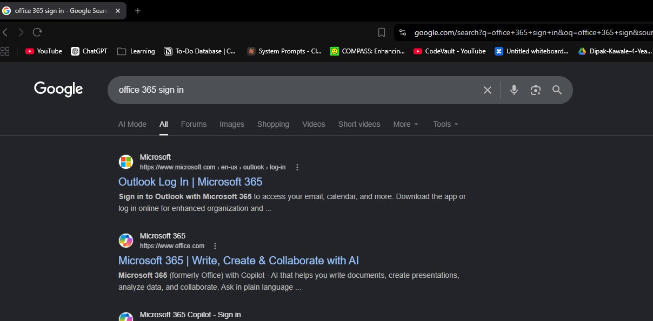

Step 2: Enter Your Email Address
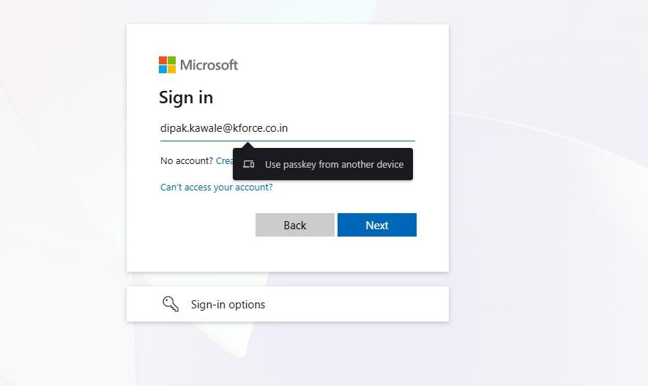
Enter your Kforce email address in the Microsoft sign-in page and click on the 'Next' button.

Step 3: Enter Your Password
On the Kforce login screen, enter your account temporary password and click on the 'Sign In' button.
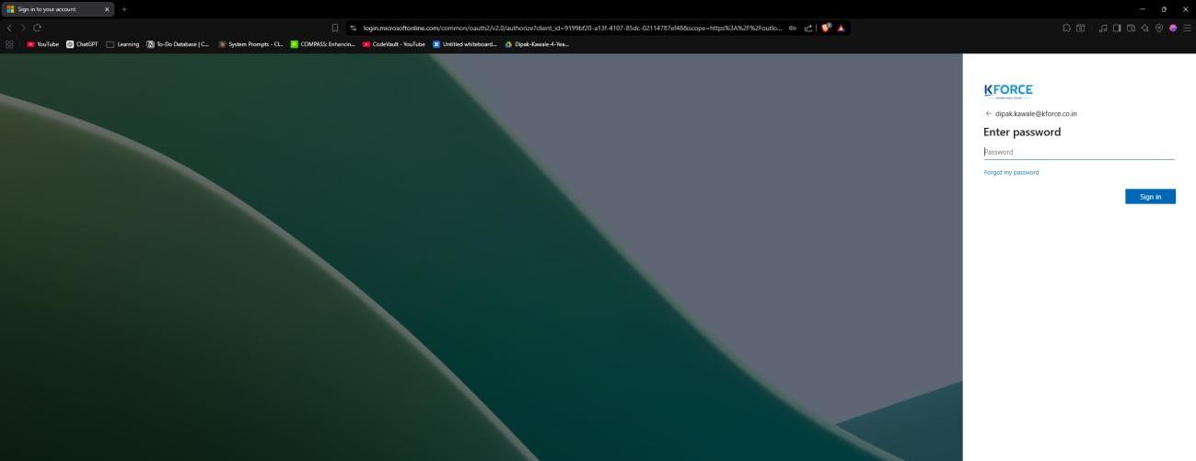

Step 4: Keep Your Account Secure
You may see a security verification message asking to keep your account secure. Click 'Next' to continue.
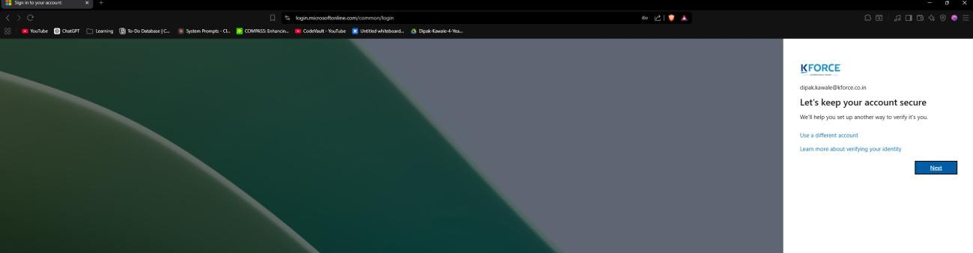

Step 5: Set Up Microsoft Authenticator
The system will ask you to set up the Microsoft Authenticator application. Install the Microsoft Authenticator app on your mobile phone and click 'Next'.

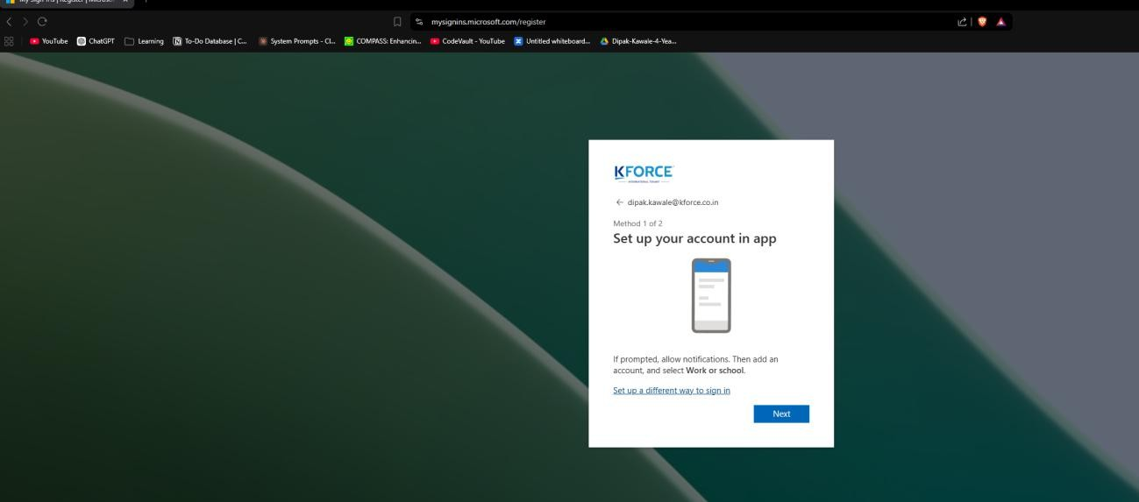

Step 6: Scan the QR Code
Click on “Next” until the QR code appears on the screen. Open the Microsoft Authenticator app on your mobile. Click on the “+” icon and select “Work or School Account”. Select “Scan a QR Code” and scan the QR code displayed on the computer screen. Complete the verification process to finish the setup.

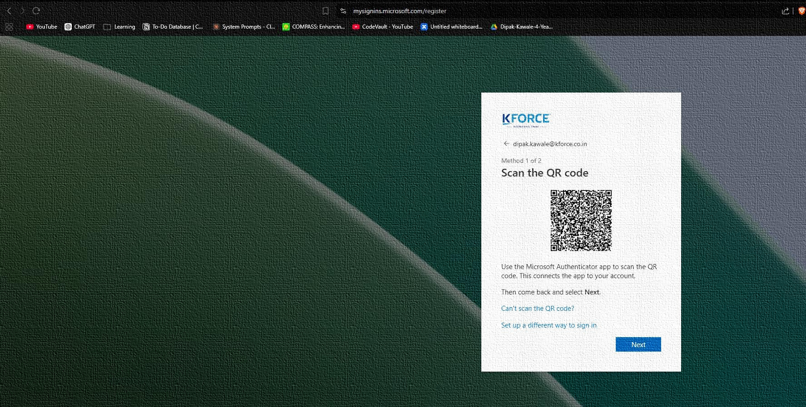

Step 7: Add Your Phone Number
Enter your country code and mobile number for verification. Select whether you want to receive the code by SMS or call, then click 'Next'.
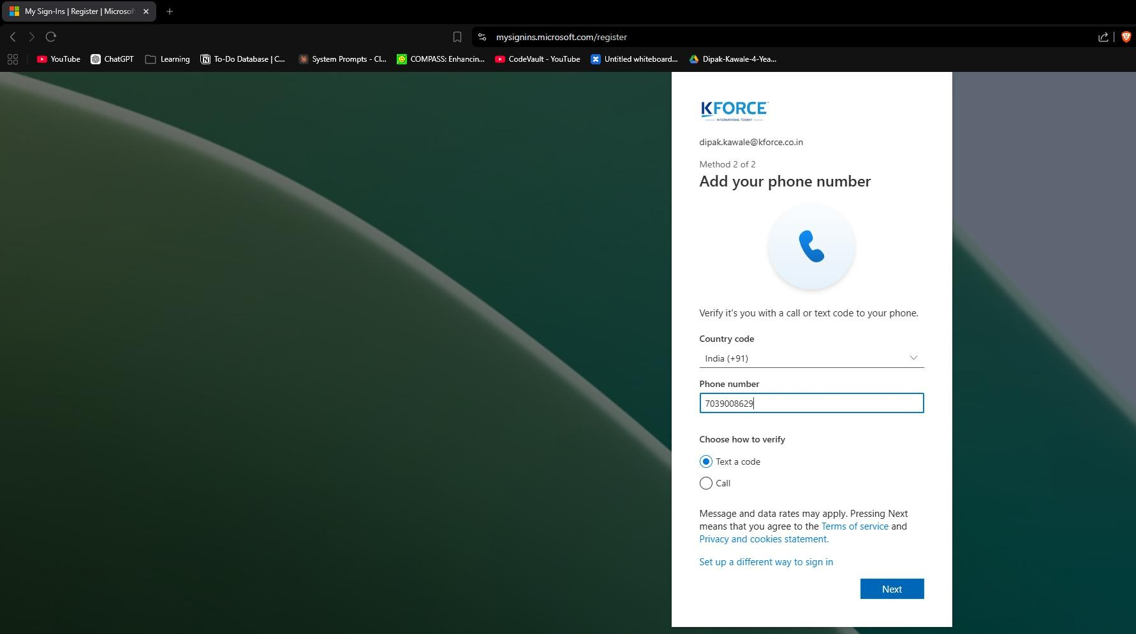

Step 8: Verify Phone Number
Enter the verification code received on your mobile number and click 'Next'.
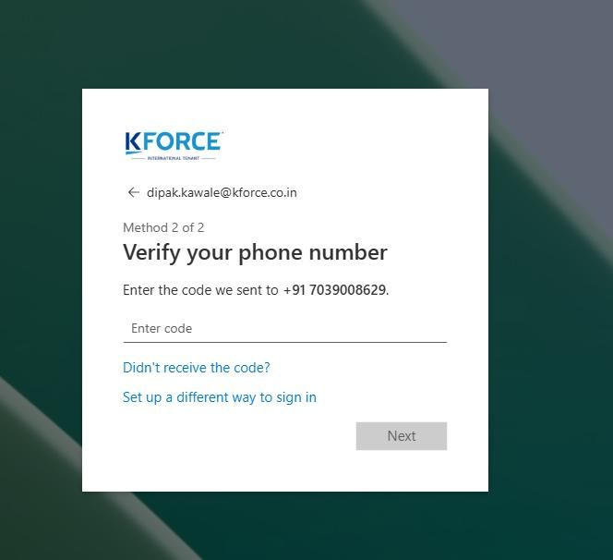

Step 9: Phone Number Added Successfully
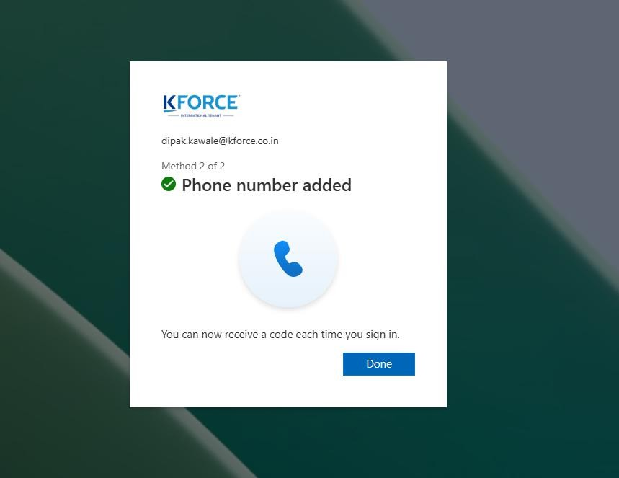
Once verification is completed, you will receive confirmation that your phone number has been added successfully. Click 'Done'.

Step 10: MFA Setup Complete
The setup process is now complete. You can use Microsoft Authenticator and your phone number for future verification.
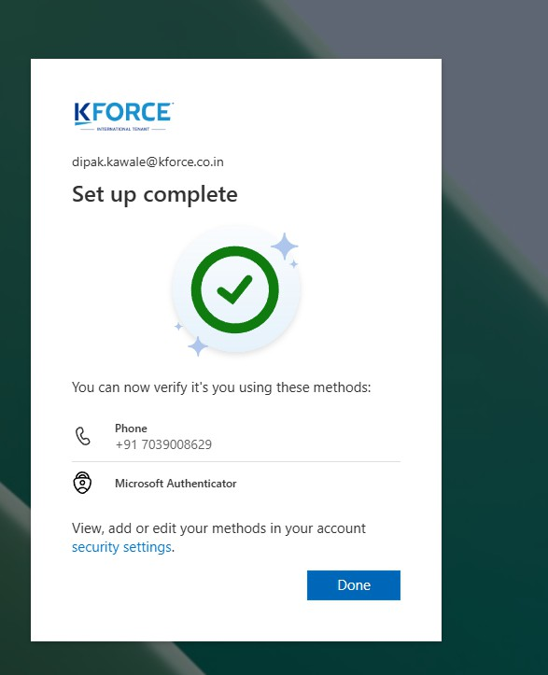

Step 11: Update Password
If prompted, create and confirm a new password for your account, then click 'Next' to finish the process.
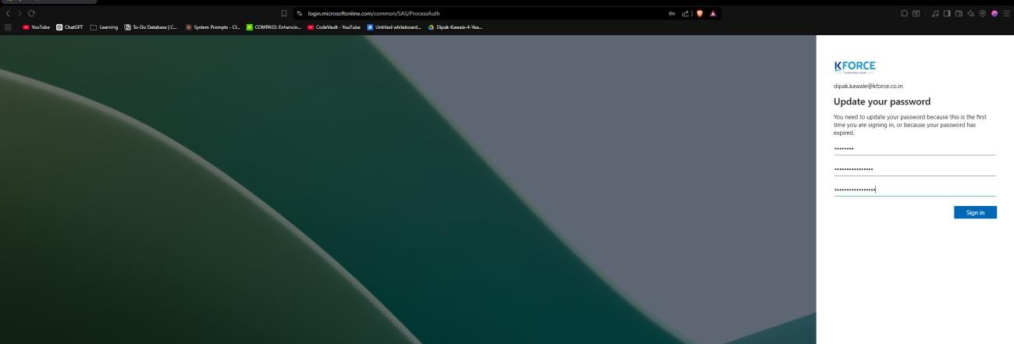

Step 12: Open Outlook and Teams in Web
After completing the MFA setup, open Outlook and Microsoft Teams in your web browser using your Kforce account credentials.
Complete the Microsoft Authenticator verification if prompted during login.
Verify that Outlook mailbox and Teams are opening successfully.
For confirmation, reply to the Test mail” shared by the IT team.
Also send a confirmation message on Microsoft Teams after successful login.

